The MA Group
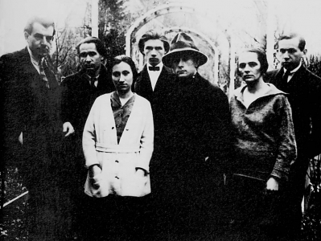

(The MA group in Vienna 1920. From left to right: Bortnyik Sándor, Uitz Béla, Újvári Erzsébet, Simon Andor, Kassák Lajos, Simon Jolán, Barta Sándor)
The Hungarian avant-garde MA (Today) group was founded by Lajos Kassák in 1916 as a successor of A Tett (The Act), which had been banned in 1915 because of its anti-militarist stance. The MA magazine was characterised by anti-militarism, Expressionist positions in literature and the visual arts, and international aspirations. The authors of MA were the left-wing writers and poets Aladár Komját, Sándor Barta and Barta Lajos, who were collaborating with the Berliner magazines Der Sturm and Die Aktion. All members of the group emigrated to Berlin after the collapse of the Hungarian Soviet Republic in 1919.
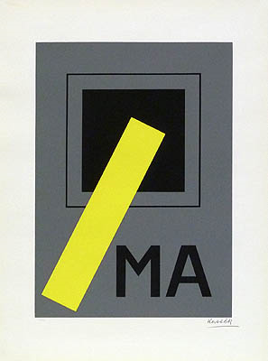
Through MA, the Hungarian avant-garde was linked to the European avant-garde. Kassák was the first Hungarian artist who maintained connections to similar European artist groups such as De Stijl, The Tempest, Die Aktion. For Kassák and his group, the activities of Die Aktion served as an example of a politically radical socialism. Kassák published articles and poems of members of Die Aktion. MA also had close ties to Der Sturm, Herwarth Walden’s gallery and magazine in Berlin. MA artists, including Róbert Berény, Lajos Kassák, Lajos Tihanyi, László Moholy-Nagy and László Peri, exhibited their works in the Sturm gallery after 1919. The MA group brought not only a unique revolutionary, politically engaged avant-garde perspective into Hungarian intellectual life before World War I, but also served as a link between Hungarian and European modernism.

References and further reading:

http://www.dada-companion.com/journals/per_ma.php
http://www.avantgarde-museum.com/en/museum/collection/4459-MA/

